**Integration of NiFi with IBM MQ on Windows-64bit**

**Prerequisite:**

1. Windows 64 bit
2. Apache Nifi 1.6.0-bin.zip (Link to download: <https://nifi.apache.org/download.html>)
3. IBM MQ Developer tools v9 (Link to download: <https://developer.ibm.com/messaging/mq-downloads/>)
4. Jdk 1.8. Make sure environment variable CLASSPATH is set.

**Run NiFi:**

1. Extract NiFi bin.zip folder
2. Open nifi.properties

* Put some value for nifi.sensitive.props.key. Eg: mysecretkey
* Put some value for nifi.ui.banner.text. Eg: nifi is cool!

1. Run run-nifi.bat file from /bin folder.

* Note: When running this file through command prompt, the prompt might close automatically. In that case, open bin folder through command prompt and run the command as follows: ‘run-nifi.bat /k’.
* Also, status of nifi can be checked by running ‘status-nifi.bat /k’ command from command prompt.
* Open <http://localhost:8080/nifi/> in chrome to open NiFi browser-UI.
* Note: When run-nifi.bat is executed, nifi.jetty server is started. It eventually starts nifi’s bootstrap process and runs commands from bootstrap.conf file.

This process can take about 2 to 15min. (As per the observation so far). So be patient until the server starts! Keep checking nifi-app.log for any info logs/warnings.

**IBM MQ:**

For installation, follow steps 1,2,3 from <https://developer.ibm.com/messaging/learn-mq/mq-tutorials/mq-connect-to-queue-manager/#win>

**Integration:**

**Use case: Put a message on the IBM queue and retrieve it through NiFi flow**

**Reference:** [**https://www.senia.org/2018/05/10/integrating-apache-nifi-with-ibm-mq/**](https://www.senia.org/2018/05/10/integrating-apache-nifi-with-ibm-mq/)

1. Open command prompt as administrator.
2. **Create a Local IBM queue manager**   
   crtmqm GSSMQP1
3. **Start the Local QMGR if it’s not already started**  
   strmqm GSSMQP1
4. **Create a Local Queue**   
   runmqsc GSSMQP1  
   define qlocal(GSS.REQUEST.REPLY.QUEUE)  
   end
5. Open users and groups.

Create group called ‘nifi’

Add default account as a member inside that group.

1. **ACL the Local QMGR for Flume and the Queue(s) being used by Nifi**

Run following commands:

setmqaut -m GSSMQP1 -t qmgr -g nifi +connect +inq +dsp  
setmqaut -m GSSMQP1 -t queue -n GSS.REQUEST.REPLY.QUEUE -g nifi +inq +browse +get +put +dsp

1. **Refresh Security on the Local QMGR**  
   runmqsc GSSMQP1  
   refresh security  
   end
2. Open nifi’s bootstrap.conf file from /conf folder.

Add following variables at the end of file:

#Additional Java arguments:

java.arg.18=-Djavax.security.auth.useSubjectCredsOnly=true

java.arg.19=-Djava.library.path=C:/Program Files/IBM/MQ/java/lib64/

java.arg.20=-Dcom.ibm.mq.cfg.jmqi.libpath=C:/Program Files/IBM/MQ/java/lib64

1. Open nifi -> Create processor group called JMS. Double click on it -> Go to ‘Setting’ inside ‘Operate’ [Icon on left side of browser window] -> Open controller services -> Add new[+] -> JMSConnectionFactoryProvider -> Go to its settings -> Rename it to IBMMQConnectionFactory -> Enable the connection factory.

**Set properties as follows:**

|  |  |
| --- | --- |
| MQ Connection Factory Implementation | com.ibm.mq.jms.MQConnectionFactory |
| MQ Client Library path | C:/Program Files/IBM/MQ/java/lib/ |
| Broker URI | Mqm |
| SSL Context Service | No value set |
| queueManager | GSSMQP1 |
| transportType | 0 |

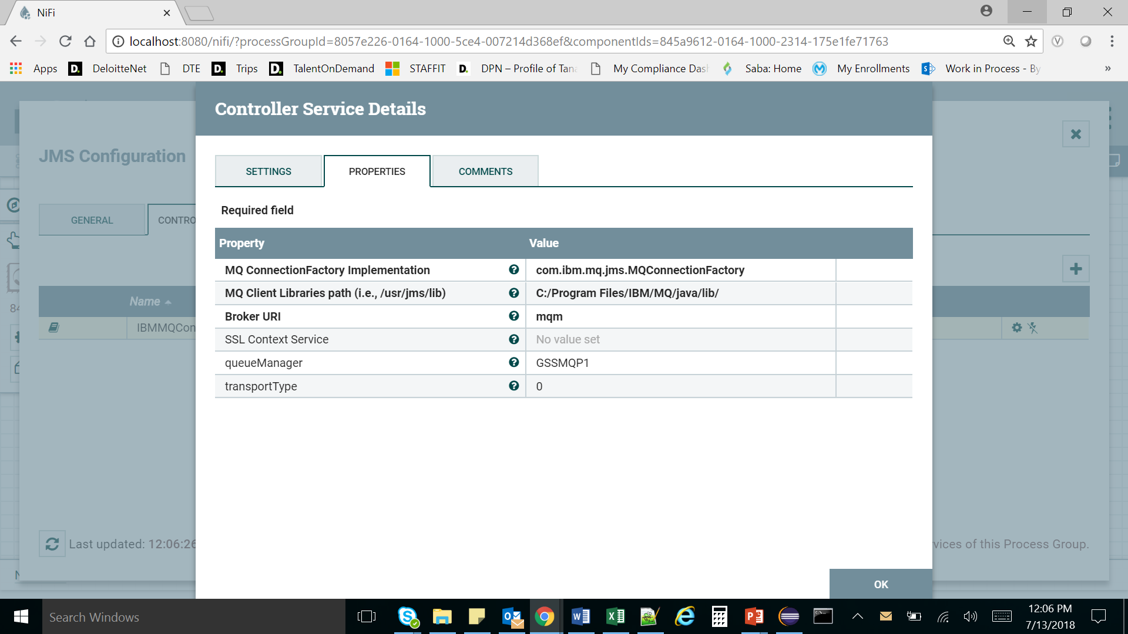

1. Go back to processor group. Create processor ‘ConsumeJMS’. Rename it as : IBMMQConsumeJMS. Set properties as follows:

|  |  |
| --- | --- |
| Connection Factory Service | IBMMQConnectionFactory |
| Destination Name | GSS.REQUEST.REPLY.QUEUE |
| Destination Type | QUEUE |
| Session cache size | 1 |
| Character set | Windows-1252 |
| Acknowledgement mode | Client-acknowledge(2) |

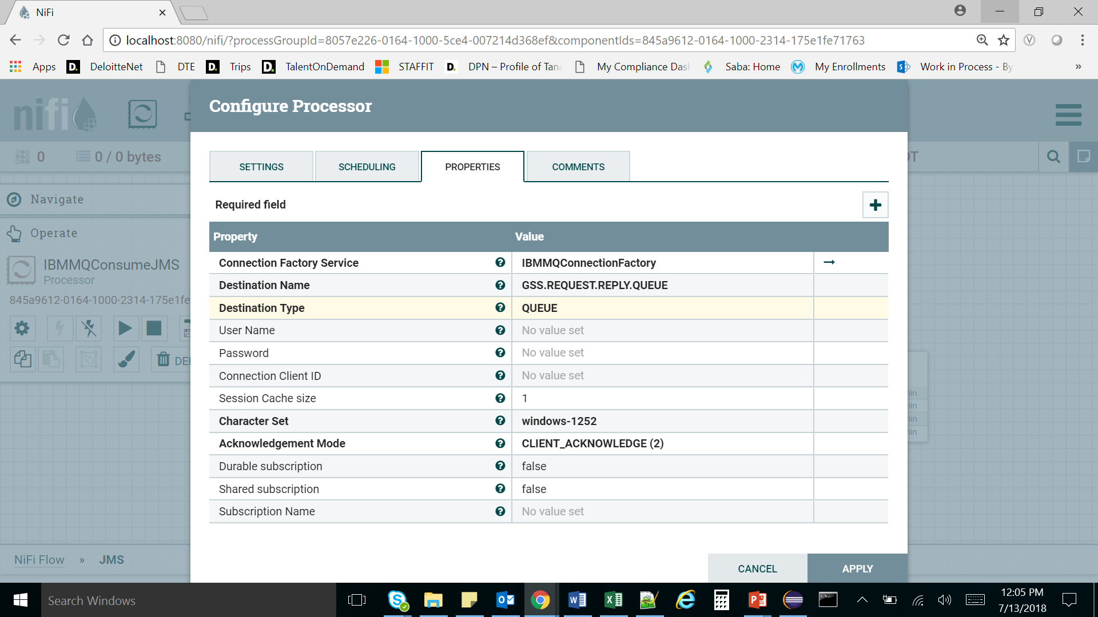

1. Add putfile processor after IBMMQConsumeJMS processor. Check success and failure to automatically terminate relationship. In properties add:

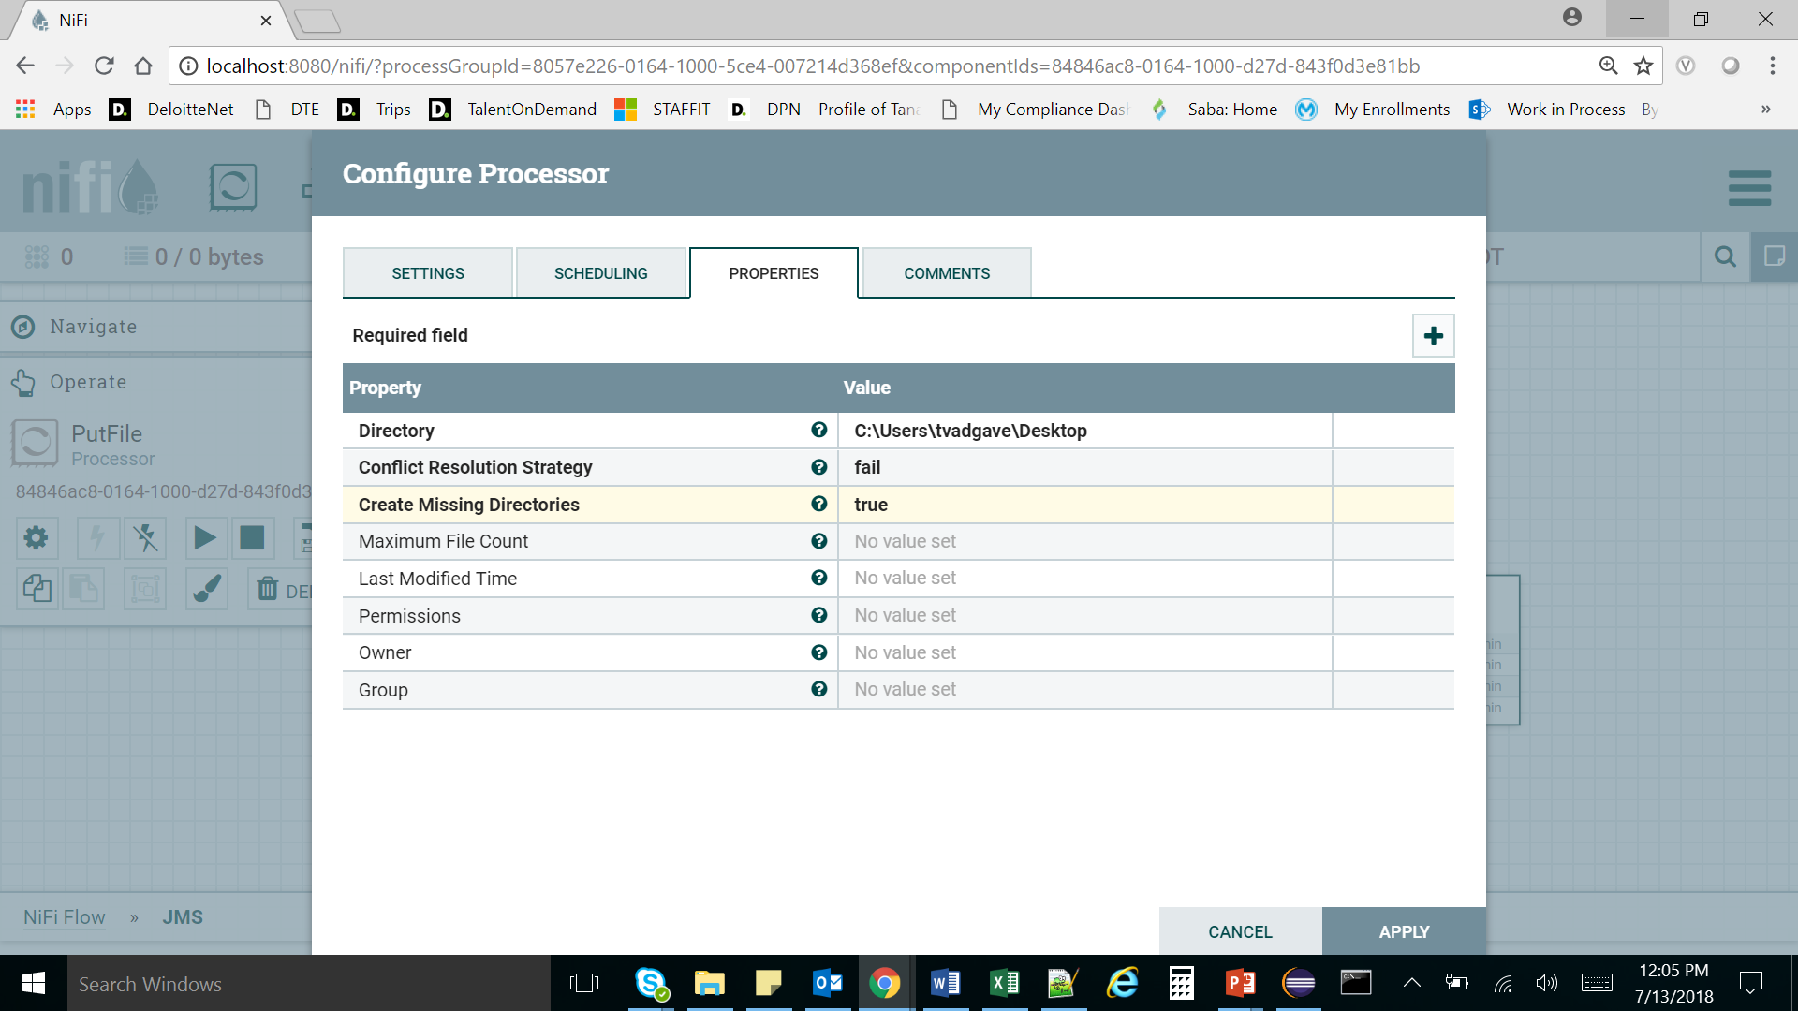

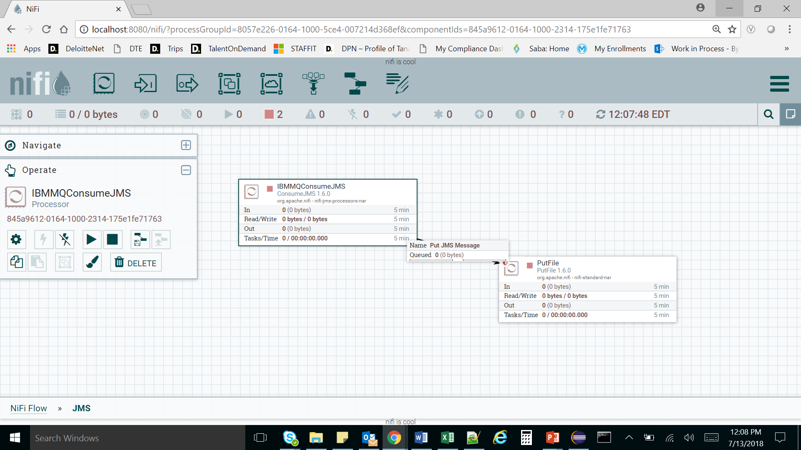

1. Select and run all processors.
2. Put message in the IBM MQ.

amqsput GSS.REQUEST.REPLY.QUEUE GSSMQP1

Hello World!

View the message ‘Hello World!’ in NiFi Putfile processor. The message can be retrieved from the file which is created by PutFile processor (refer directory location specified in processor’s configuration)!!!